**CO-Sensor working: changing from UART4 to UART2**

Dates worked: 06/20 (8 hours), 06/21 (8 hours)

Summary of work:

1. CO-sensor is a spec sensor used for measuring gas concentration in ppb, temperature and humidity. So initially I imported the mcu_code project in STM32 Workbench from the link provided by the professor (<https://drive.google.com/drive/folders/17m4F4N4_kkOTDOFqWLUxq0XmNoPkaU7n?usp=sharing>)
2. I had to study the freertos implementation of the code in main.c to understand the working and modify few things as per our application and study the usart2 configuration in stm32cubemx. Studying took about 3-4 hours on 06/20
3. Following steps are followed to configure the USART2 using STM32CubeMX:
4. In STM32CubeMX, start a new project-->go to board selector-->select B-L475E_IOT01A discovery kit

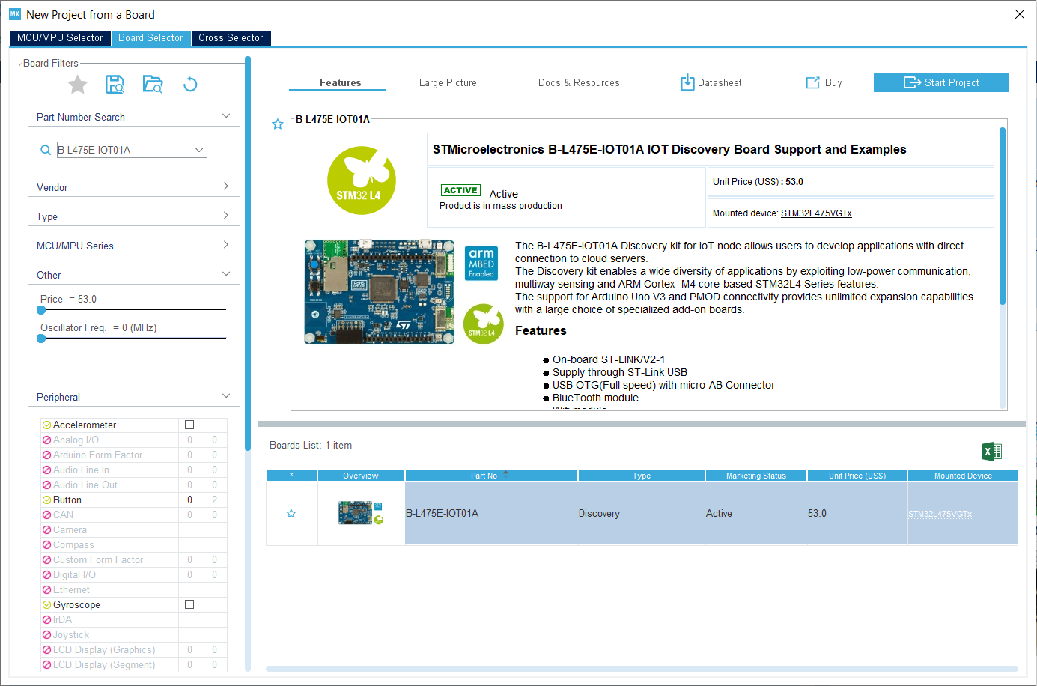

2) After selecting, go to pin diagram and make the following changes

ARD_D10-->USART2_TX

ARD_D4-->USART2_RX

3) On the left side of the window, Go to connectivity-->USART2-->Change from disable to Asynchronous, hardware flow control-->keep disable. Change baud rate to 9600

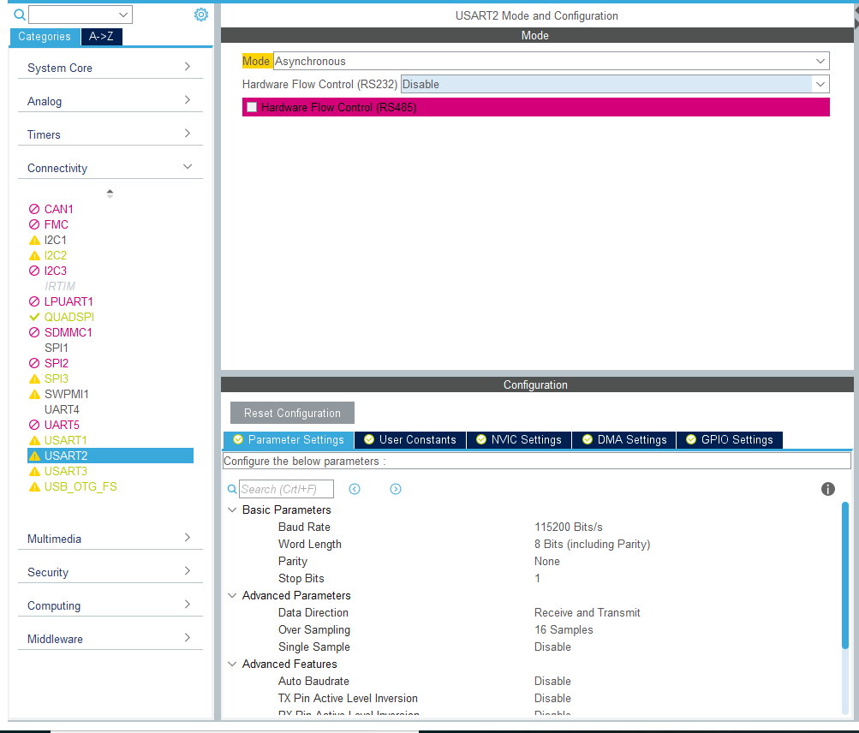

4) Go to NVIC Settings--> Enable the USART2 Global Interrupt

5) Go to Middleware-->Select FreeRTOS-->Select CMSIS V1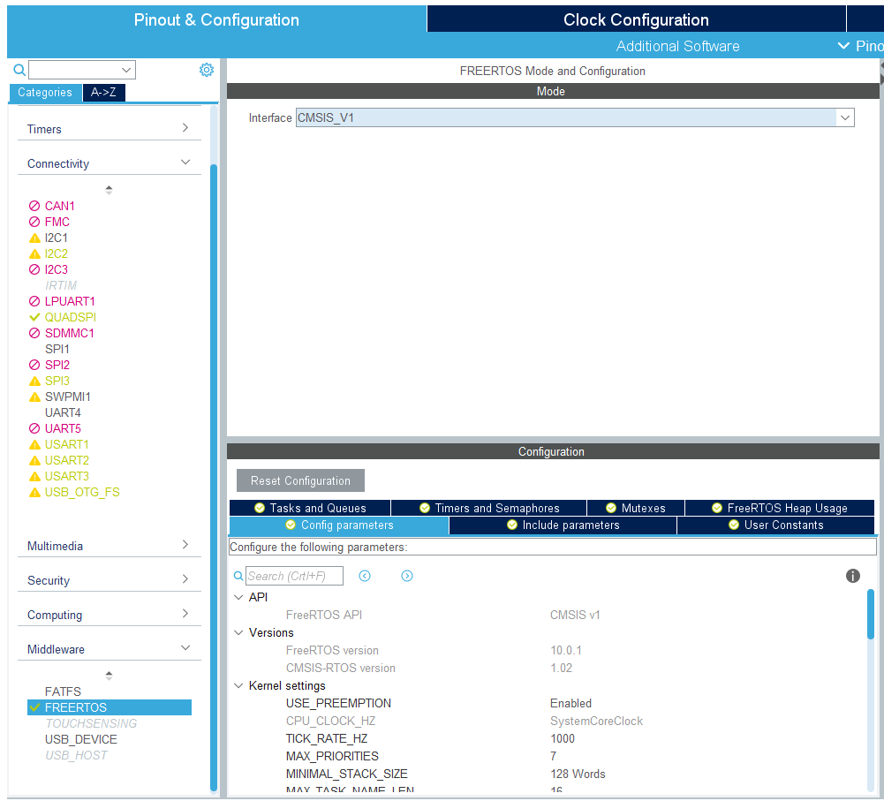

6) Go to System Core-->SYS-->Timebase Source-->Select TIM1

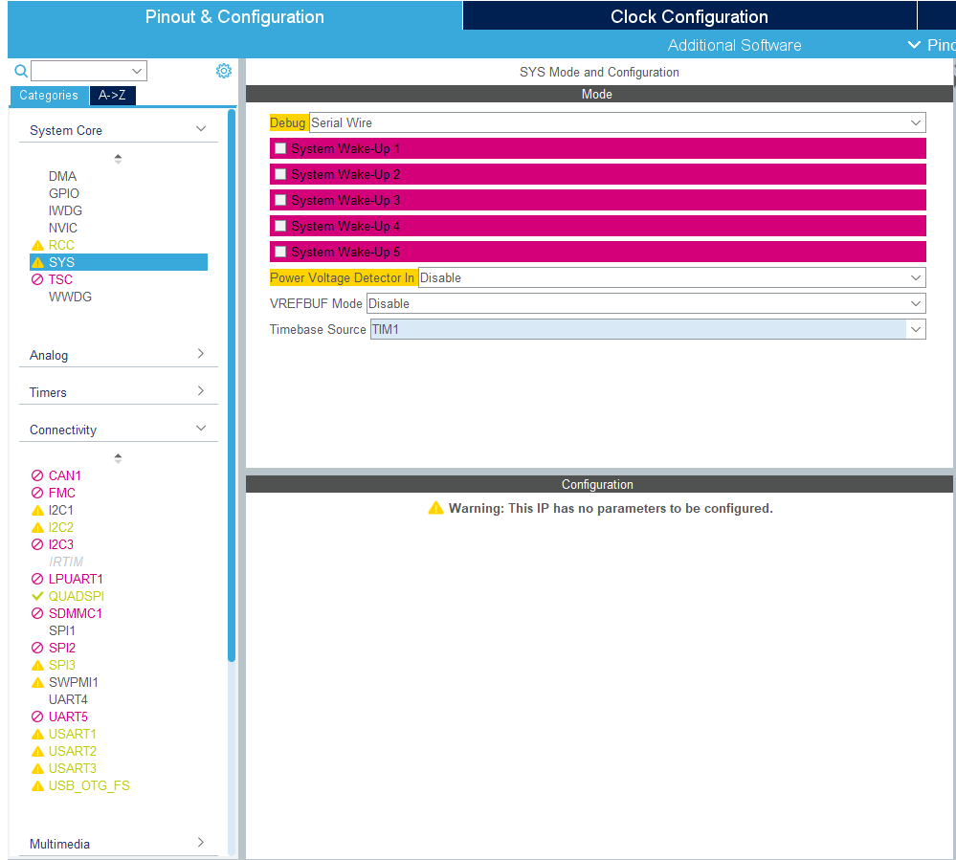

5) Go to Project Manager-->Give a project name and location where it needs to be saved. Keep the application structure basic. Select Toolchain as **“SW4STM32”.** Firmware package shall be default. It will ask to download and install the STM32Cube_FW_L4 package, go ahead and install it.

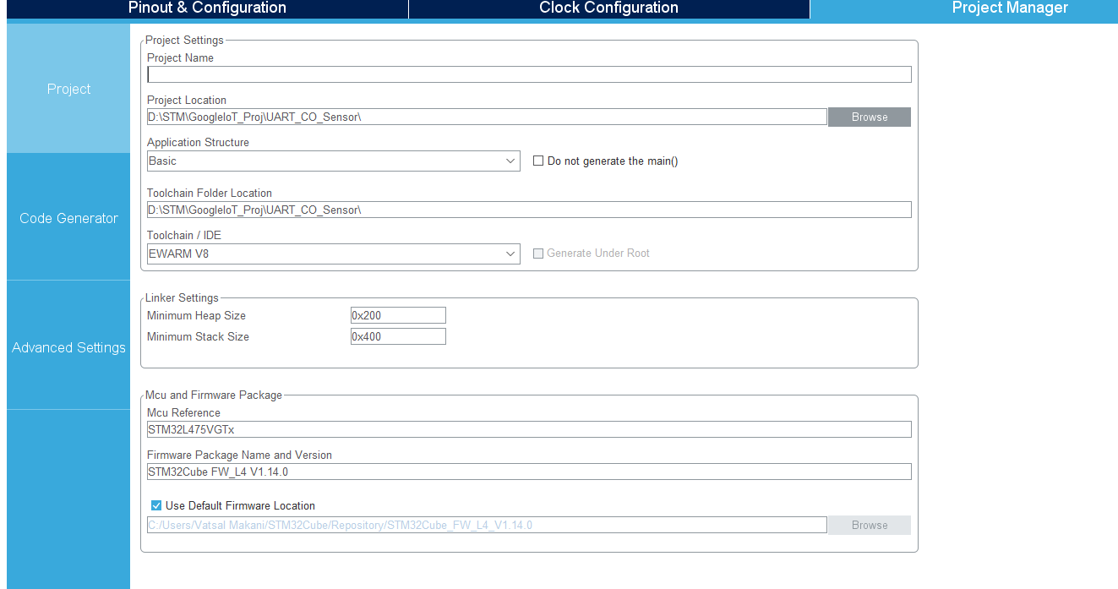

6) Save the project and open the project in STM32 Workbench. Copy the contents of main.c from mcu_code to this main.c

7) JUST COPY THE VARIABLES, FUNCTIONS DEFINITIONS, main() body, UART_RxCallback() (Change from uart4 to uart 2), StartDefaultTask() ((Change from uart4 to uart 2), modify the stm32xxmsp.c, stm32xxit.c and main.h wherever necessary.

8) Compile the code and run in debug mode

9) Go to teraterm--> terminal->receive->AUTO, transmit->LF, Enable Local Echo. Go to serial port-->Baud rate: 115200

10) Output shall be as follows



The microcontroller sends the character “c” over UART2 to CO-Sensor. As per sensor datasheet, character ‘c’ signifies the following:

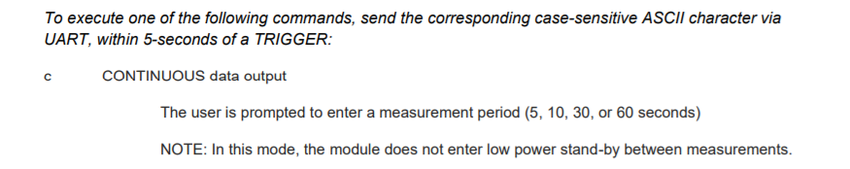

Once it get ‘c’, sensor starts sending data over UART2, the format of the output is

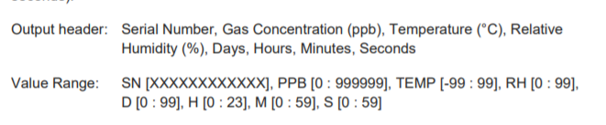

In our case, we are getting output as **“#2, 121818012824, 1283, 24, 52, 13402, 26684, 30898, 00, 00, 34, 18”**

Where:

SN: 121818012824

Gas concentration: 1283 ppb

Temperature: 24 deg C

Humidity: 52%

Time Elapsed: 0 days 0 hours 34 minutes 18 seconds.

**Challenges:**

1. **In Spite of doing the configuration properly in CubeMX, it was not able to trigger the UART to communicate.**

Solution: During configuring for the first time, i did not enable UART2 global interrupt and did not select TIM1 in System Core option. After including them, sensor started sending data over UART

**Milestone: Before configuring UART2, co-sensor required a separate STM Discovery**

**Board to work since GPS and CO-Sensor both used UART4. Now with the help of**

**UART2, just a single discovery kit is required to control GPS and CO-Sensor**

**simultaneously.**